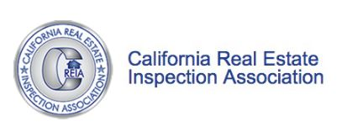
California Real Estate Inspection Association
1540 River Park Drive, Suite 211
Sacramento, CA 95815
916-634-4219
info@creia.org
www.creia.org

SELF-PROVING AFFIDAVIT OF INSPECTIONS
Applicant's Name
Address
City, State, Zip
Phone Number
Today's Date
Dear CREIA Membership Committee,
I am providing this affidavit to verify completion of 1,000 fee-paid inspections for the Master CREIA Inspector - Level 1 application. I understand these inspections must be performed solely by the CCI applicant or lead by the CCI applicant with other CREIA or ASHI Certified Inspectors.
The applicant's records and statements shall be subject to audit, as seen fit by the Board of Directors in accordance with the CREIA Standards of Practice. I certify that the information presented in this letter is true and correct to the best of my knowledge and belief.

Sincerely,
Signature of applicant
Printed name of applicant

